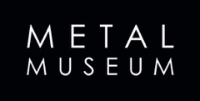
Media Contact:
Jenn Godwin, Communications Manager
(901) 774-6380 | jenngodwin@metalmuseum.org
374 Metal Museum Drive, Memphis, TN 38106

News Release
Metal Museum opens traveling exhibition RINGS! 1968 - 2021 featuring over 100 works from international artists
Visitors invited to March 26 make-your-own ring class followed by opening reception

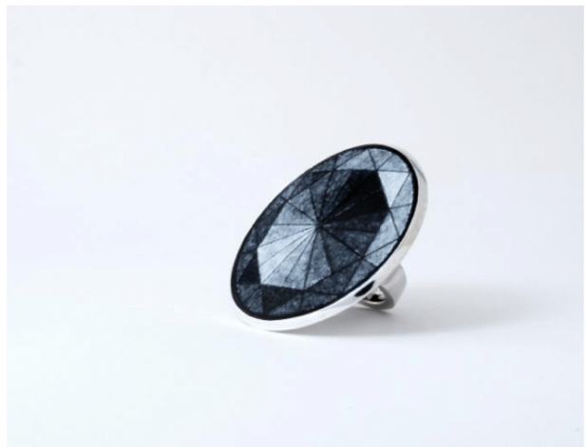

Bury 1_rings-284: Claus Bury (German, b. 1946), Ring, 1970. Gold, acrylic. Promised Gift of the Helen Williams Drutt Family Collection, Museum of Fine Arts, Houston. Photo: Virigina Price.

Mimlitsch Gray 1: Myra Mimlitsch-Gray (American, b. 1962), Grisaille Ring, 1991. Grisaille enamel on copper, silver. Artwork and Photo Courtesy of the Artist.

MEMPHIS, Tenn. (March 8, 2022) – Selected as the third national stop for a traveling exhibition of contemporary jewelry, the Metal Museum opens RINGS! 1968 - 2021 on March 27, showcasing over 100 pieces created by artists from around the world, including countries such as India, Japan, New Zealand and Ukraine. An opening reception will take place from 3 - 5 p.m. March 26, with a drop-in ring-making class for visitors inspired to create their own wearable works of art.

RINGS! celebrates the wide-ranging creativity of established masters and emerging makers whose techniques range from traditional to contemporary. Unconventional and timeless all at once, this colorful collection emphasizes the relevance of jewelry across cultures while also serving as a historic archive of contemporary jewelry.

The exhibition, which opened in 2021 at Moore College of Art & Design in Philadelphia before moving to the Houston Center for Contemporary Craft at the beginning of 2022, will be at the Metal Museum through June 12, 2022. The exhibition highlights many works owned by Helen Drutt, a renowned educator, gallery owner and advocate of contemporary craft who has been called America’s ambassador for craft around the world.

“[Contemporary jewelry] reflects our time in history. It reflects the expansion of materials and technology that are available to us or not available to us in other decades or centuries,” said Drutt. “It’s a badge of knowledge; it’s a mark of your own experience and your own pageantry. It’s an amazing thing.”

Drutt’s diverse experiences in the art world began with her taking art lessons as a child in the 1930s and include training as an artist, starting an interior design firm in Philadelphia, creating the Inter-Society on Twentieth Century Decorative Arts and Design and teaching at the Philadelphia College of Art and Moore College of Art & Design. Now 91, Drutt brings her extensive background and deep knowledge to this exhibition, adding historic context and scholarly weight to the sizable collection of rings on display.

A universal form across places and cultures, rings have long held significant meaning throughout history, often denoting relationship status, membership or a personal conviction or achievement. This exhibition will surprise and delight those who take a moment to appreciate its scope, because even though the works themselves are modest in size, the impact of rings on modern life as a jewelry piece, form of self-expression and singular fashion statement cannot be understated.

A selection of rings from the Metal Museum’s Permanent Collection also accompanies this exhibition, while the Education Department will have a drop-in class on March 26 for visitors to make their own pewter ring using the cuttlefish casting technique. In addition, the Metal Museum Store will have a display of rings from more than a dozen living artists for purchase.

Event Details:
RINGS! 1968-2021 opens March 27, and closes June 12. The exhibit will be on display in the Gasparini Galleries. An opening reception with Helen Drutt will take place from 3 - 5 p.m. Saturday, March 26, with a special members-only preview beginning at 2 p.m.
Two drop-in ring-making classes will be offered, the first session from 11 a.m. - noon and the second from 1 - 2:30 p.m. The class will use the cuttlefish casting technique and is $25 per casting.

About the Metal Museum
The Metal Museum is the only institution in the United States devoted exclusively to the preservation, promotion, and advancement of the art and craft of fine metalwork. This mission is achieved through four primary program areas – exhibitions, collections, studio practice, and community education and engagement. Programs are facilitated on the Museum grounds and at locations across the Mid-South. Located on 3.2 acres of historic property overlooking the Mississippi River, the Museum grounds include the main Museum building as well as the Metalworking Facilities, Library + Resource Center, and private artist residences. Learn more about the Museum and its programs by visiting our website at metalmuseum.org.
The Museum receives operating support from ArtsMemphis and the Tennessee Arts Commission. Programming support is received from Hyde Family Foundation, the Windgate Charitable Foundation, and hundreds of corporate, foundation, and individual supporters.

High-resolution images of artwork and exhibit graphics are available upon request. Please contact Jenn Godwin, Communications Manager for the Metal Museum, at (901) 774-6380 or jenngodwin@metalmuseum.org.

